NAME:V.Navyasree
REG NO:192373050

6.Write the python program for Cript-Arithmetic problem
Program:
from itertools import permutations

for p in permutations(range(10), 8):
s,e,n,d,m,o,r,y = p if s == 0 or m == 0:
continue
send = 1000*s+100*e+10*n+d more = 1000*m+100*o+10*r+e money = 10000*m+1000*o+100*n+10*e+y
if send+more == money: print("SEND =", send) print("MORE =", more) print("MONEY =", money)
break Output:
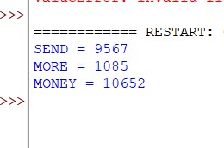
7. Write the python program for Vacuum Cleaner problem
Program:
room = {'A': 'Dirty', 'B': 'Dirty'}
location = 'A'

while 'Dirty' in room.values(): print("Location:", location) if room[location] == 'Dirty': room[location] = 'Clean' print(location, "cleaned")
else:
location = 'B' if location == 'A' else 'A'

print("All rooms are clean") Output:
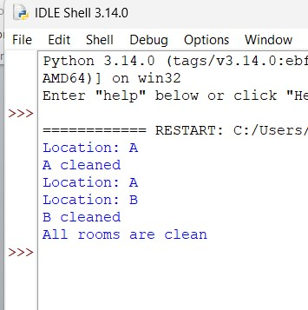
8. Write the python program to implement BFS.
Program: graph = {
'A': ['B', 'C'],
'B': ['D', 'E'],
'C': ['F'],
'D': [],
'E': [],
'F': []
}

visited = [] queue = ['A']

while queue:
node = queue.pop(0)
if node not in visited: print(node, end=" ") visited.append(node) queue.extend(graph[node]) Output:
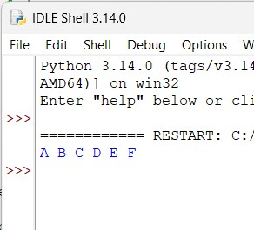
9. Write the python program to implement DFS.
Program: graph = {
'A': ['B', 'C'],
'B': ['D', 'E'],
'C': ['F'],
'D': [],
'E': [],
'F': []
}

visited = set()

def dfs(node): if node not in visited: print(node, end=" ") visited.add(node) for i in graph[node]:
dfs(i)

dfs('A')
Output:
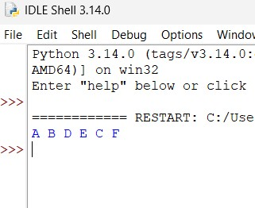
10. Write the python program to implement A* algorithm Program: graph = {
'A': [('B', 1), ('C', 3)],
'B': [('D', 1), ('E', 5)],
'C': [('F', 2)],
'D': [], 'E': [], 'F': []
}

h = {'A': 4, 'B': 3, 'C': 2, 'D': 0, 'E': 1, 'F': 0}

open_list = [(h['A'], 0, 'A', ['A'])]

while open_list: open_list.sort()
f, g, node, path = open_list.pop(0)

if node == 'D':
print("Path:", path) print("Cost:", g) break

for next_node, cost in graph[node]:
new_g = g + cost
open_list.append((new_g + h[next_node], new_g, next_node, path + [next_node])) Output:
